**HomeView**

**Project Plan**

Uniting Streaming Services on One Site

February 2, 2022

Unite

Christian Lam

Daniel Monge

Eric Truong (Team Leader)

Erina Lara

Michael Lamera

Table of Contents

**Overview** **3**

Assumptions and Constraints 3

**Resources** **4**

Team 4

Document Resources 4

**Project Timelines** **4**

Project Timeline 4

Roadmap 7

Hour-Sprint Distribution & Information 9

Production Deployment 13

**Project Maintenance and Control** **14**

Requirements Management 14

Time and Budget Control 14

Costs 14

**Risk Assessment** **15**

**References** **21**

# Overview

* 1. Project Overview  
       
     Our team is aiming to solve a browsing and convenience problem. Subscribers of multiple American streaming services experience difficulty in trying to find a specific title to watch or to experience something new. As cited by Wonder (research company), the average Netflix user spends around 20.75 minutes of their day, or 126 hours of their year, spent searching for titles to watch. Moreover, searching for new movies or shows involves logging in to each platform individually, and dealing with separate browsing catalogs. In addition, although American streaming services already offer a free way for users to view their catalog, users are able to view each of their subscription’s catalog collectively on our site, rather than taking more time to view each individually. Our product will serve as an organized, customized database and comfortable American streaming service navigator. The vision of HomeView is to provide clients with an effortless stream searching experience while also unifying all different American streaming services.

## 

* 1. Document Overview  
       
     The following document contains relevant information regarding the entire timeline, roadmap, risks and its mitigations, resources, and its constraints.

## Assumptions and Constraints

| **#** | **Assumptions** |
| --- | --- |
| 1 | User has access to an internet connection |
| 2 | User has access to a system capable of running Google Chrome 93 or up |
| 3 | User owns an email address |
| 4 | User is subscribed to at least one streaming subscription service |
| **#** | **Constraints** |
| 1 | Project deadline is May 2022 |
| 2 | Team Unite has five members |
| 3 | Team members are full time students |
| 4 | No budget |

# Resources

## Team

| **Name** | **Role** |
| --- | --- |
| Christian Lam | Full Stack Developer |
| Daniel Monge | SCRUM Master / Full Stack Developer |
| Eric Truong | Team Leader / Full Stack Developer |
| Erina Lara | Full Stack Developer |
| Michael Lamera | Full Stack Developer |

## 

## Document Resources

| **Document** | **Link** |
| --- | --- |
| Timeline | <https://lucid.app/lucidchart/460c3ef9-374a-4dee-a3a4-4b1442c977ec/edit?view_items=ms7X_Us66qCk&invitationId=inv_d167f3e1-c6f4-4b6d-af3a-661aad61c5c0> |
| Roadmap | <https://lucid.app/lucidchart/82fec267-e8bd-4d26-8bdc-1aecd64eb7ba/edit?viewport_loc=-20%2C-35%2C1579%2C832%2C0_0&invitationId=inv_bbbfa89f-482a-4b37-af61-213b108735ce> |

# Project Timelines

## Project Timeline

## 

## 

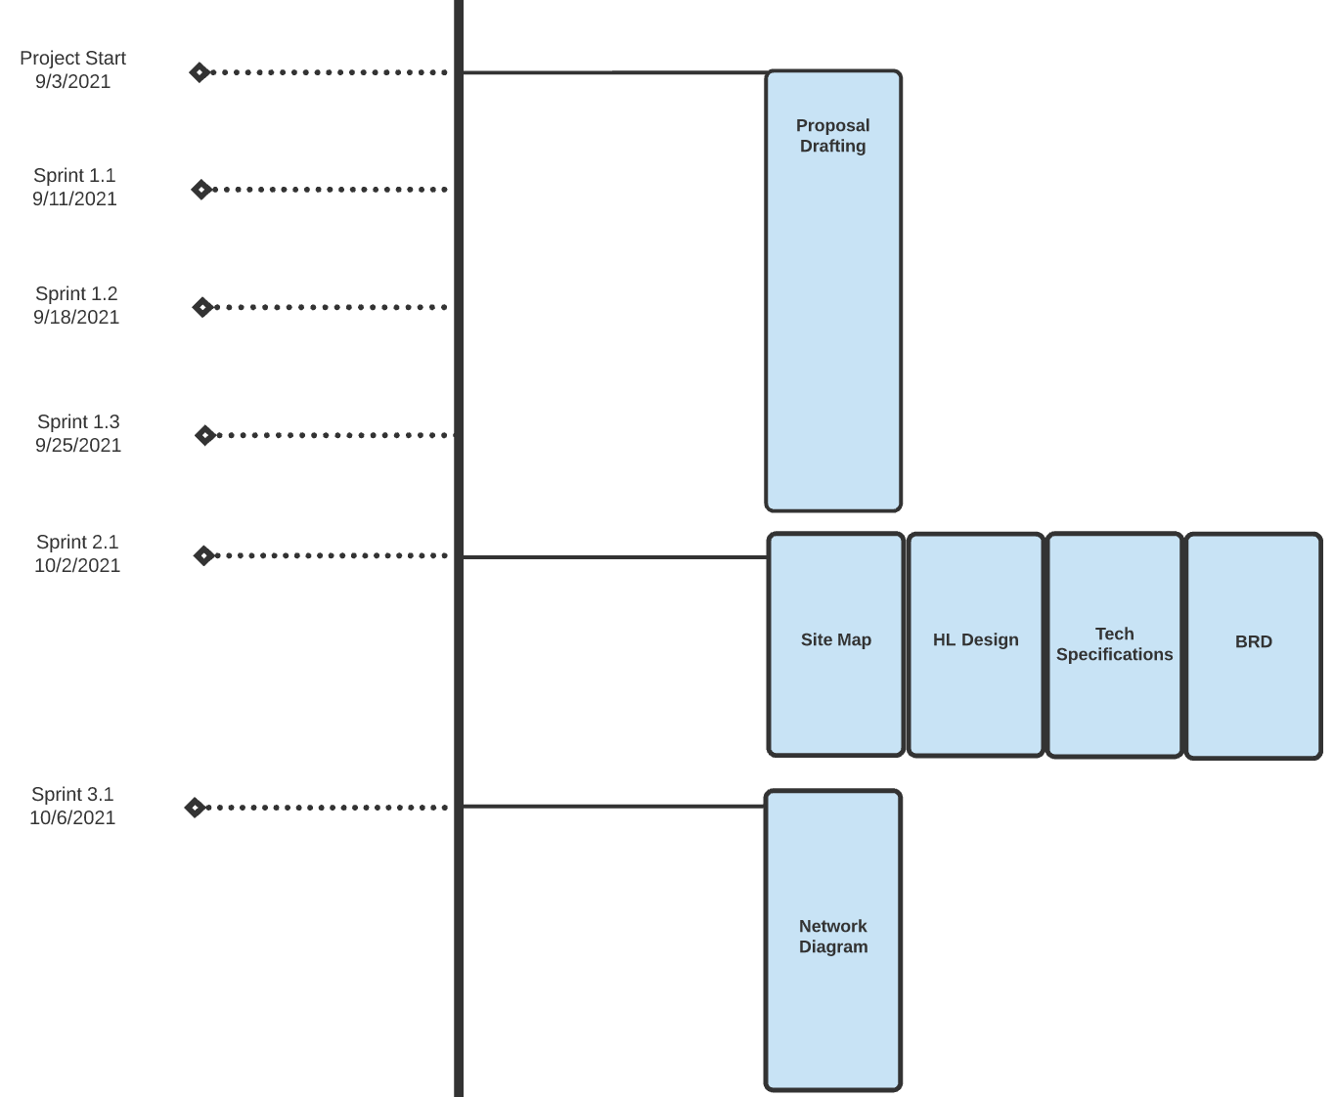

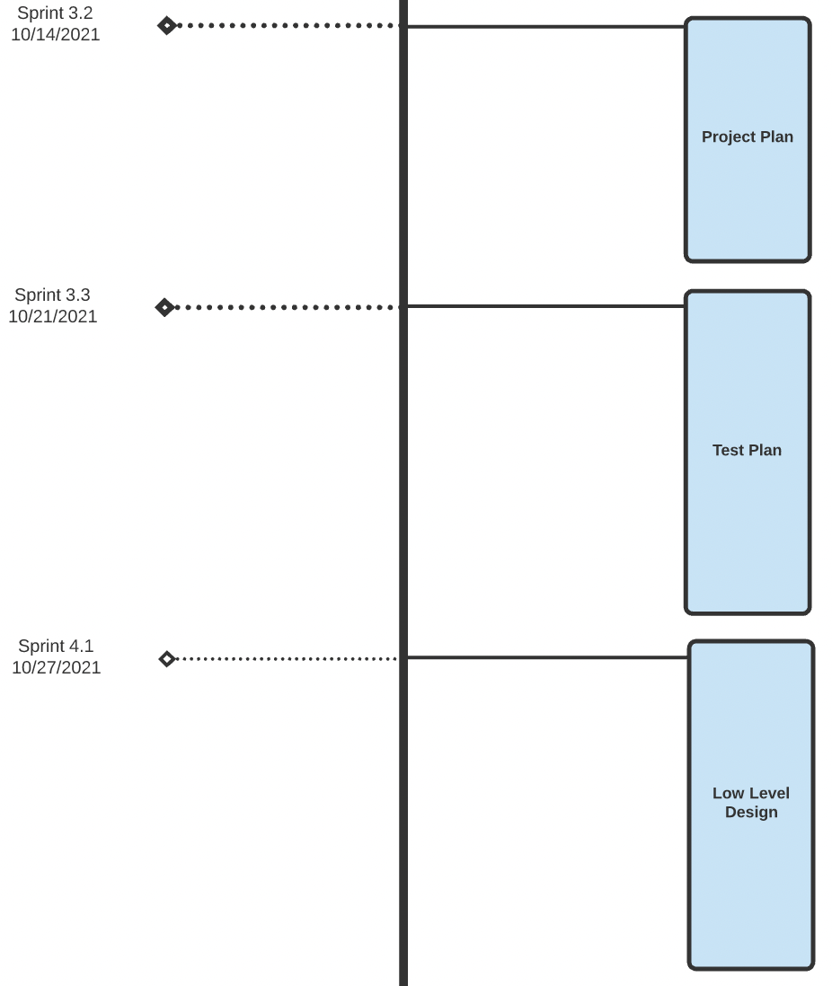

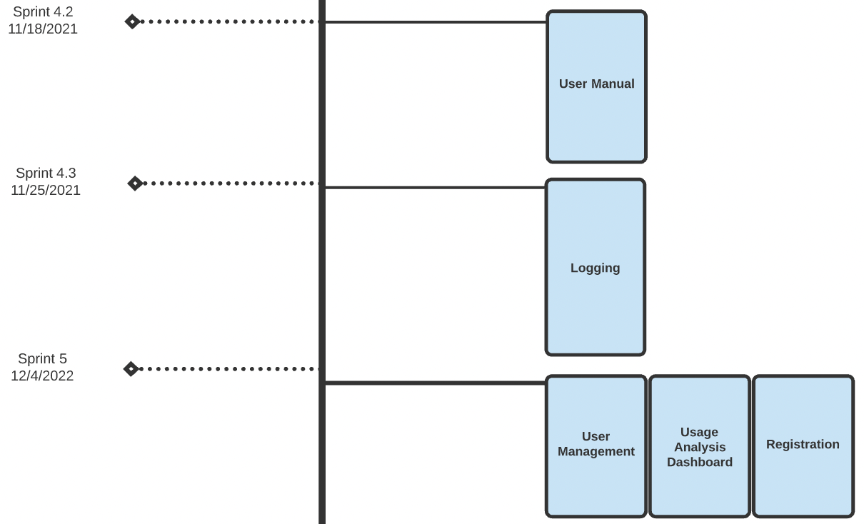

## 

## 

## Roadmap

## 

Note: Milestone deliverables after Milestone 3 and dates after 12/4/2021 are anticipated and are subject to change, due to a new semester

| **Milestone** | **Sprint #** | **Description** | **Deliverables** | **Start Date** | **Completion Date** |
| --- | --- | --- | --- | --- | --- |
| Project Start | N/A | Begin brainstorming the main idea and features of the project. | N/A | 8/28/2021 | 9/3/2021 |
| Proposal Approved | N/A | Write a document detailing the main idea, features, why it’s needed, and get it approved. | Project Proposal | 9/3/2021 | 9/29/2021 |
| Milestone 1 | 1.1-1.3 | Draft up the Site Map, High Level Design, Tech Specifications, Business Requirements Document, and submit them.. | Site Map, High Level Design, Tech Specifications, Business Requirements Document | 9/30/2021 | 10/6/2021 |
| Milestone 2 | 2.1 | Draft up the Project Plan, Test Plan, Network Diagram, and submit them. | Project Plan, Test Plan, Network Diagram | 10/7/2021 | 10/27/2021 |
| Milestone 3 | 3.1-3.3 | Draft up the Low Level Design for core requirements and features and submit them. | Low Level Design, User Manual, Logging | 10/28/2021 | 12/4/2021 |
| Milestone 4 | 4.1-4.7 | Code the User Management, Usage Analysis Dashboard, and Registration features. | User Management, Usage Analysis Dashboard, Registration | 12/4/2021 | 2/14/2022 |
| Milestone 5 | 5.1 | Code the Login/Logout, User Access Control, and Central Media Library features. | Login/Logout, User Access Control, Central Media Library | 2/14/2021 | 3/14/2022 |
| Milestone 6 | 6.1 | Code the Playlist, Blacklist, and Central Media Library features. | Playlists, Blacklist, Central Media Library | 3/14/2021 | 4/11/2022 |
| Milestone 7 | 7.1 | Code the Central Media Library, News, ActWiki, and Ratings and Reviews features. | Central Media Library, News, ActWiki, Ratings and Reviews | 4/11/2021 | 5/1/2022 |
| Project End | 8.1 | Project code is finished and ready for deployment on online web services. | Finished product | 5/1/2021 | 5/1/2022  **(Deployment Date)** |

## 

## Hour-Sprint Distribution & Information

| Sprint 1 | | |
| --- | --- | --- |
| 9/11/2021 - 9/25/2021 | **Project Proposal**  21 hours | **Productive**  21 hours |
| Work Items:  Sprint 1.1:   * Specify scope of web project * Support claim of streaming services losing revenue * Provide more detail on application features * Support statement our service allowing users to save money * Specify supported browser and version * Feedback from client (Confirmation)   Sprint 1.2:   * Application Restrictions own section * Specify how data will be fetched * How will playlists be shared * How will users know if playlist updated, removed, etc * VPN Feature (confusing) * How will users be notified of changes to titles   Sprint 1.3:   * Reformat proposal to appear more professional * Add table of contents * Explicitly specify browser version restriction and support * Add user option to opt out of email notifications * Add article age order * Add an Expansion section * Remove implementation details | |

## 

| Sprint 2 | | |
| --- | --- | --- |
| 10/2/2021 - 10/6/2021 | **BRD, Tech Spec, HL Design, Site Map**  99 hours | **Productive**  99 hours |
| Work Items:  Sprint 2.1:   * BRD - Include project overview * BRD - Glossary of terms * BRD - Business Requirements * BRD - Use cases * BRD - Complete project details * Site Map - Create list of pages * Site Map - Create errors for pages * HL Design - Design Diagrams * HL Design - Create descriptions * Tech Spec - Hardware Requirements * Tech Spec - General Technology Specifications * Tech Spec - Product Technology Specifications * Tech Spec - Security Specifications | |

## 

| Sprint 3 | | |
| --- | --- | --- |
| 10/7/2021 - 10/27/2021 | **Project Plan, Test Plan, Network Diagram**  173 hours | **Productive**  68 hours  **Non-productive**  105 hours |
| Work Items:  Sprint 3.1:   * Network Diagram - Network Diagram * Network Diagram - Technologies * Network Diagram - Protocol * Network Diagram - Network Flow   Sprint 3.2:   * Project Plan - Overview * Project Plan - Resources * Project Plan - Risk Assessment Risks * Project Plan - Risk Assessment Mitigations * Project Plan - Timeline * Project Plan - Roadmap * Project Plan - Hour Sprint Distribution * Project Plan - Project Maintenance and Control * Project Plan - References   Sprint 3.3:   * Test Plan - Test Policy, Overview * Test Plan - Feature Level Scenarios - Logging/Archiving, Datastore, * User Interface (UI) Testing * Test Plan - Feature Level Scenarios - Central Media Library, Playlists Testing * Test Plan - Feature Level Scenarios - Registration, User Management, Login, Logout Testing * Test Plan - Feature Level Scenarios - Blacklist, Ratings and Reviews Testing * Test Plan - Feature Level Scenarios - ActWiki, News Testing * Test Plan - Document Resources | |

## 

| Sprint 4 | | |
| --- | --- | --- |
| 10/27/2021 - 12/4/2021 | **Low Level Design, User Manual, Logging**  - 331 hours | **Productive**  - 314 hours  **Non-productive**  - 17 hours |
| Work Items:  Low Level Designs for all of the following:  Sprint 4.1:   * User Admin - Registration * User Admin - Account Deletion * User Management - Creating New User Records * User Management - Modify User Records   Sprint 4.2:   * System Observability - Usage Analysis Dashboard * System Observability - Logging * System Observability - Archiving * Central Media Library - Recommended Movies/TV shows * Central Media Library - Popular Movies/TV Shows * Central Media Library - Genres * Central Media Library - Only Movies * Central Media Library - Only TV shows   Sprint 4.3:   * Playlist - Playlist Creation * Playlist - Playlist Deletion * Playlist - Adding Playlist Contributor * Playlist - Removing Playlist Contributor * Playlist - Inserting Media into Playlist * Playlist - Removing Media from Playlist * Playlist - Change User's Permissions * Playlist - Opt-in/out of Playlist Notifications * Playlist - Access Playlists   Sprint 4.4:   * Blacklist - View Blacklist * Blacklist - Add actor/actress to Blacklist * Blacklist - Remove actor/actress from blacklist * Blacklist - Add a genre to blacklist * Blacklist - Remove genre from blacklist * Blacklist - Enable/Disable user's blacklist   Sprint 4.5:   * Ratings and Reviews - Select a Rating * Ratings and Reviews - Write a Review * Ratings and Reviews - Delete a Review * Ratings and Reviews - Error Handling   Sprint 4.6:   * ActWiki - Show ActWiki * ActWiki - Search for Actor/Actress * News - Publish Article * News - Delete an Article * News - Show Article Information * News - Show News Page   Implementation Items:  Sprint 4.7:   * User Management classes implementation * User Management Unit Testing * Logging and Archiving Unit Testing * Logging implementation * Archiving implementation * Project Setup | |

## The following hour-sprint tables will be updated as more sprints are completed.

| Sprint 5 | | |
| --- | --- | --- |
| 12/4/2022 - 2/14/2022 | **User Management, Usage Analysis Dashboard, Registration**   * Approximately 400 hours | **Productive**  - hours  **Non-productive**  - hours |
| Work Items:  Sprint 5.1:   * User Management Testing and Debugging * Usage Analysis Dashboard Implementation * Usage Analysis Dashboard Testing and Debugging * Registration Implementation * Registration Testing and Debugging | |

## 

| Sprint 6 | | |
| --- | --- | --- |
| 2/14/2022 - 3/14/2022 | **Login/Logout, User Access Control, Central Media Library**   * Approximately 400 hours | **Productive**  - hours  **Non-productive**  - hours |
| Work Items:  Sprint 6.1:   * Login/Logout Implementation * Login/Logout Testing and Debugging * User Access Control Implementation * User Access Control Testing and Debugging * Central Media Library Implementation * Central Media Library Testing and Debugging | |

## 

| Sprint 7 | | |
| --- | --- | --- |
| 3/14/2022 - 4/11/2022 | **Central Media Library, Playlists, Blacklist**   * Approximately 400 hours | **Productive**  - hours  **Non-productive**  - hours |
| Work Items:  Sprint 7.1:   * Central Media Library Implementation * Central Media Library Testing and Debugging * Playlists Implementation * Playlists Testing and Debugging * Blacklist Implementation * Blacklist Testing and Debugging | |

## 

| Sprint 8 | | |
| --- | --- | --- |
| 4/11/2022 - 5/1/2022 | **Central Media Library, News, ActWiki, Ratings and Reviews**   * Approximately 400 hours | **Productive**  - hours  **Non-productive**  - hours |
|  | Work Items:  Sprint 8.1:   * Central Media Library Implementation * Central Media Library Testing and Debugging * News Implementation * News Testing and Debugging * ActWiki Implementation * ActWiki Testing and Debugging * Ratings and Reviews Implementation * Ratings and Reviews Testing and Debugging | |

## 3.4 Production Deployment

* Estimated total time: 2,224 hours (92 days)
* Monitoring and logging system setup to keep check on the live system
* Production setup documented to bits (system configs, system specifications, installation instructions)
  + Updated when any change is made to production environment of the system

# Project Maintenance and Control

## Requirements Management

In order to track our progress for the project and to ensure timely execution and

completion of all deliverables and requirements necessary for the project, our

team will be utilizing the SCRUM methodology. We will commit to sprint

reviews and client meetings to discuss and apply client feedback or changes to the

project after every sprint.

## Time and Budget Control

For each milestone, we have gathered the scheduled completion date for our

deliverables, as well as the estimated dates for upcoming milestones. Our budget

for this project is $0, therefore we will only be utilizing free software and

hardware to create and deploy our product.

## Costs

* Software Developers - $0
  + Developers are full-time students and are pursuing this application to fulfill their senior project. Therefore, the developers are not being paid a living wage.
* Microsoft Visual Studio 2019 Community Edition - $0
  + Microsoft Visual Studio 2019 is an IDE used to develop the application using C# and the .NET framework.
* Microsoft SQL Server Management Studio - $0
  + Microsoft SQL Server Management is used to create a local database on the developer’s computers to easily test certain parts of the code.

# Risk Assessment

All risks will be listed in order of greatest priority first and least priority last, along with their mitigation.

Risk Impact will be defined as either:

* High (Has a widespread, severe, or critical impact towards the entire scope of the project in which the entire project may be compromised)
* Medium (Has a serious, or focused impact towards significant parts of the project in which some services of the project may be compromised)
* Low (Has a minor, insignificant impact towards the project in which the entire scope of the project is still able to function and services are not gravely affected)

Risk Probability will be defined as either:

* High (Likelihood of happening is likely or almost certain)
* Medium (Likelihood of happening is possible or unlikely)
* Low (Likelihood of happening is negligible or rare)

1. Group members becoming unavailable
   1. There is a possibility that a member could be absent from doing any self-assigned task and/or does not communicate with the team
   2. **Impact**: High
   3. **Probability**: Medium
   4. **Threshold**: September 2021
   5. **Mitigation**: After the first instance of a group member not responding to the team or not completing a task that was self-assigned, the team will allow a one-day grace period for the member to get back to them. If they fail to get back to the team, then the team will notify Professor Vong
2. Unforeseen circumstances
   1. There is a possibility that a member would be unable to work on the project due to an uncontrollable situation, such as a car accident, familial matters, health reasons, or the like
   2. **Impact**: High
   3. **Probability**: Low
   4. **Threshold**: September 2021
   5. **Mitigation**: All documents and source code will be uploaded to GitHub allowing all members to be able to access any work that needs to be finished. Additionally, all tasks will be finished in a timely manner
3. Unfamiliarity with programming languages, software, and/or hardware
   1. There is a possibility that a member may be unfamiliar with a certain programming language, framework, or hardware
   2. **Impact**: High
   3. **Probability**: High
   4. **Threshold**: December 2021
   5. **Mitigation**: If a member is unfamiliar with any of the tech stack materials or programming languages, hardware, or software, then the member will have to spend extra time researching said topic along with learning about said topic from a knowledgeable member
4. Member dropping or failing a semester
   1. There is a possibility of a member not receiving a passing grade in the first semester and not being able to take the second part of the course
   2. **Impact**: High
   3. **Probability**: Medium
   4. **Threshold**: January 2022
   5. **Mitigation**: Work with the member to produce quality work in a timely manner
5. Members having personal issues with another member
   1. There is a possibility of multiple members having disagreements on project-related issues or personal issues
   2. **Impact**: Low
   3. **Probability**: Low
   4. **Threshold**: September 2021
   5. **Mitigation**: Identify and discuss the issue with each member individually to discover the root cause of the issue. If the issue is project-related, discuss possible solutions with the team. If the issue is personal, ensure that each member remains professional and keeps personal issues or emotions outside of the work setting
6. Project not meeting specifications
   1. There is a possibility of the project not having a finished feature or the feature does not live up to expectations
   2. **Impact**: Medium
   3. **Probability**: Medium
   4. **Threshold**: December 2021
   5. **Mitigation**: Ensure that all members carefully follow the use cases outlined in the Business Requirements Document to ensure that the features meet the specifications
7. Client and user dissatisfaction with product
   1. There is a possibility of the client and user having issues with a certain feature or does not live up to expectations
   2. **Impact**: High
   3. **Probability**: Low
   4. **Threshold**: September 2021
   5. **Mitigation**: Hold weekly meetings with the client in order to receive updated client feedback regarding all aspects of the project and its deliverables
8. Streaming services requiring us to cease the project
   1. There is a possibility that streaming services would disapprove of their application being used and would request the project to halt
   2. **Impact**: High
   3. **Probability**: Low
   4. **Threshold**: September 2021
   5. **Mitigation**: Ensure that project specifications and implementations are not in violation of any of the streaming services’ policies by reviewing each services’ documentation and policies
9. Project giving inaccurate information on links
   1. There is a possibility that the original webpage would be edited causing users to be sent to an error page
   2. **Impact**: Medium
   3. **Probability**: Low
   4. **Threshold**: May 2022
   5. **Mitigation**: If at any point a change must be made to a webpage, any links that were given out beforehand must be updated to ensure it is up to date
10. Data breach
    1. There is a possibility that a security flaw would be present and adversaries would be able to steal sensitive information
    2. **Impact**: High
    3. **Probability**: Medium
    4. **Threshold**: May 2022
    5. **Mitigation**: We will ensure that our databases will be accessible only by people who are required to interact with it, and any data being stored will be encrypted
11. Developers ignore given tasks
    1. One of the developers may decide to slack and not complete tasks
    2. **Impact**: High
    3. **Probability**: Medium
    4. **Threshold**: December 2021
    5. **Mitigation**: The other members will find out why they are stuck and how the problem can be solved. If the slacking continues the member will be removed
12. Low Stakeholder/Client Engagement
    1. Client or stakeholder we are collaborating with is not engaging with the team at the frequency necessary to maintain high productivity levels. Slow response can impede delivery timeframes
    2. **Impact**: High
    3. **Probability**: Medium
    4. **Threshold**: September 2021
    5. **Mitigation**: Clear agreements with the client or stakeholders around response times and have an effective selection of delivery and project goals/priorities
13. Lack of Ownership
    1. Team fails to assign direct ownership of a task to a team member. Then, no one has sole responsibility for the task being delivered and no one is accountable for the successes and failures of it
    2. **Impact**: Medium
    3. **Probability**: Low
    4. **Threshold**: September 2021
    5. **Mitigation**: Set ownership and responsibilities of tasks to only one team member. Other team members can contribute, but only one person is responsible for the task being delivered
14. Poor Quality Code
    1. Code has the possibility of being poor quality. Meaning it’s difficult for other developers to review and make changes. Code may have also been rushed and released without testing and be full of bugs that could have been prevented
    2. **Impact**: High
    3. **Probability**: Medium
    4. **Threshold**: December 2021
    5. **Mitigation**: Implement clear coding standards and guides. Have code reviews with team members. Test all of the code before release
15. Communication services being interrupted
    1. The services we use to communicate and plan out our progress of the product can affect the scrum process
    2. **Impact**: High
    3. **Probability**: Low
    4. **Threshold**: September 2021
    5. **Mitigation**: Ensure that all members are signed up for and use a backup communication service, such as phone-calling, texting, Slack, or Discord
16. Spring semester schedules
    1. New schedules next semester could change the team’s capacity
    2. **Impact**: High
    3. **Probability**: Medium
    4. **Threshold**: January 2022
    5. **Mitigation**: Ensure that all members of the team are able to enroll in the same 491B class section. If a member is not able to enroll in the same section, a meeting with the 491B Professor must be held to request for a replacement team member or to review possible alternative solutions
17. Clients misunderstand product
    1. Clients can mistake that the product allows them to watch any tv show / movie on one site, however we direct them to a specific streaming site
    2. **Impact**: Low
    3. **Probability**: Low
    4. **Threshold**: September 2021
    5. **Mitigation**: Ensure that User Manual and product’s About section accurately provides a detailed explanation regarding the usage and purpose of the product
18. Requirements for the project could change
    1. The client could result to asking for more features to implement
    2. **Impact**: High
    3. **Probability**: Low
    4. **Threshold**: September 2021
    5. **Mitigation**: Developers will prepare for the idea of future implementations throughout meetings with the client
19. Features may be too difficult
    1. Features become too challenging and will delay completion and delivery
    2. **Impact**: High
    3. **Probability**: Medium
    4. **Threshold**: January 2022
    5. **Mitigation**: Developers will ensure they will seek help from each other and try to accomplish the obstacle
20. Database files are lost
    1. Losing the files for the databases will lose all the clients information
    2. **Impact**: High
    3. **Probability**: Medium
    4. **Threshold**: January 2022
    5. **Mitigation**: Constantly create copies of the files within the database servers
21. Memory space limit
    1. The necessary storage amount provided could be less than anticipated
    2. **Impact**: High
    3. **Probability**: Low
    4. **Threshold**: December 2021
    5. **Mitigation**: Acquire more memory from the service providers if needed
22. Funding needed
    1. Funds may be needed to help polish the product
    2. **Impact**: Medium
    3. **Probability**: Low
    4. **Threshold**: September 2021
    5. **Mitigation**: Developers would possibly put in a small amount of funds for the product

# References

Risk Assessment

<https://www.castsoftware.com/research-labs/risk-management-in-software-development-and-software-engineering-projects>

<https://www.edureka.co/blog/risk-analysis-in-software-testing/>

<https://codebots.com/way-of-working/what-are-the-10-biggest-risks-in-software-development>

Project Timeline

<https://www.projectmanager.com/project-timeline>

Project Roadmap

<https://www.projectmanager.com/blog/tips-for-project-roadmap>